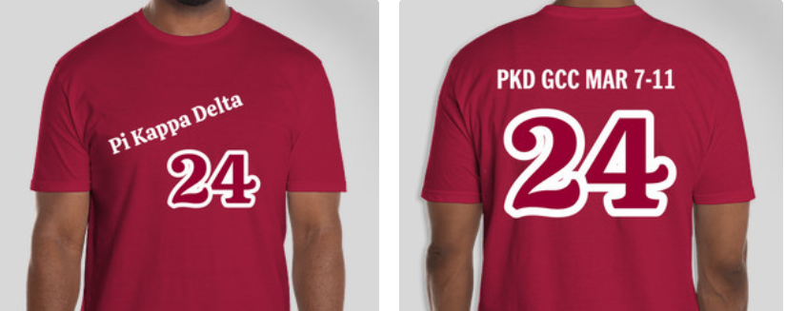

PKD 2024 T-shirt Order Form
Please send completed order form to ablood@uwf.edu by February 26, 2024

Name
Email
Cell
Payment will be processed via credit card payment link sent to email. T-shirts will be delivered to teams at the 2024 Biennial.

Size | Price | Quantity | Total
Small | $20.00
Medium | $20.00
Large | $20.00
XL | $20.00
XXL | $20.00
Total

